POS/ EON Test Plan

Approvals
Name | Function | Date | Signature
Sunil Yusuf | Project Manager
Badusha
Asif

Revision History
Rev. | Date | Author | Description
0.1 | November 02, 2016 | Raghuraman Swaminathan | Initial draft
0.2
1.0
This page intentionally left blank
Table of Contents
1 Introduction 5
1.1 Purpose 5
1.2 Scope 5
1.3 Terms, Acronyms and Abbreviations 5
1.4 References 6
2 Test Goals and Criteria 7
2.1 Test Approach 8
2.2 Requirements Coverage Goals 9
2.3 Test Initiation Criteria 9
2.4 Test Completion Criteria 10
2.5 Test Suspension/Resumption Criteria 10
2.6 Build Turn over Process 10
3 Types of Testing 11
3.1 Functional Testing 11
3.1.1 Test Case Generation Approach 11
3.1.2 Test Reuse Approach 11
3.1.3 Test Automation Approach 12
3.1.4 Test Prioritization Approach 12
3.2 Application testing 12
3.2.1 Test Case Generation Approach 12
3.2.2 Test Reuse Approach 12
3.2.3 Test Automation Approach 12
3.3 Capacity and Performance Testing 12
3.3.1 Test Case Generation Approach 12
3.3.2 Test Reuse Approach 12
3.3.3 Test Automation Approach 12
3.4 SIT testing 12
3.4.1 Test Case Generation Approach 12
3.4.2 Test Reuse Approach 12
3.4.3 Test Automation Approach 13
3.5 Usability testing 13
3.5.1 Test Case Generation Approach 13
3.5.2 Test Reuse Approach 13
3.5.3 Test Automation Approach 13
4 Defect logging and Tracking process 14
4.1 Defect Tracking Tool 14
4.2 Defect Severity 14
4.3 Defect Life cycle 14
5 Configuration Management 15
6 Test Cycles 16
6.1 Application Testing – Cycle I 16
6.2 Application Testing – Cycle II 16
7 Test Resources 18
7.1 Test Team 18
8 Test Environment 19
8.1 TB1 – Application and PAT Test bed 19

9 Test Execution Plan 20
Appendix A Test Session Summary 21

Introduction

Purpose
The purpose of the Test Plan is to document the goals and objectives of testing, the test strategy, the items to be tested, the approach to be taken, and the test resource requirements for EON Program.
A brief introduction to EON Program:
EON program is targeted to develop a customized POS system for Fuel station business
.
Point of Sale (POS) System is an upgraded version of the traditional cash register. A POS System generally includes the following components: POS software, computer, monitor, credit card reader, cash drawer, barcode scanner, and receipt printer. It performs all of the same functions of a cash register, but doesn’t stop there. What truly stands out about a POS System is the work it does during and after the transaction. After updating inventory changes in real time and capturing customer information, a POS System really shines in its ability to contribute to the overall efficiency of a retail store.

The system is more complex and is tightly integrated with other software systems like Warehouse, Inventory, purchase order, supply chain, marketing, merchandise planning etc.

As part of the first phase, only basic functions of the fuel station use cases will be targeted, and this test plan is designed to cater to the testing needs of these basic features only. This test plan shall be further updated with the test requirements of additional Features, as and when they are materialized.

Scope
This is the integrated test plan which is targeted to cover the complete testing needs of EON project, which includes,
- Functionality Testing
- Performance Testing
- Stability Testing
- Report Testing
- SIT testing needs at System level
There shall be individual test design/test suite documents prepared subsequently based on the directions given in this test plan for each of the above listed testing phases, if required.
This document also details out the Assumptions / Constraints / Dependencies, Risks & Mitigation plans, Training needs, Simulation, Automation, test bed on which the tests shall run, the tools to be used, hardware needs, efforts, resources, deliverables and entry, exit criteria related to testing.

Terms, Acronyms and Abbreviations
Below are the terms, acronyms, and abbreviations used within this document. Additional project-specific terms can be found in the project glossary.
Term, Acronym, Abbreviation | Definition
PAT | Product Acceptance Testing
SIT | System Integration Testing
PCR | Product Change Request
TBD | To Be Determined
SIS | Software Interface Specification
LAN | Local Area Network
PCT Testing | Peformance Capacity and Topology Testing
CCB | Change Control Board. Change Control Board in this document refers to the body which consists of representatives from Project/Program management, Testing, Development and Marketing teams who are mostly the functional leaders in their respective groups and are directly assoicated/responisble for EON project delivery. This Change Control Board would be responisble for taking decisions like whether to defer a particular issue or not, whether to plan for a patch release should we experience a priority issue from field etc.  In addition, this Change Control Board should also be responisible for making decisions in various circumstances as mentioned in the test plan.

References
Abbreviation | Reference Element | Description

NOTE 1: Revision information is given in the above table as part of the Description column.

Test Goals and Criteria

Test Approach
The below diagram depicts the complete test strategy to be adapted for EON program.
The hardware related testing (board level testing, pre-compliance tests – EMI, EMC, Thermal, and certifications), shall NOT be part of the scope of this project. However the functional testing of Field Interface will be planned to validate the functional behavior.
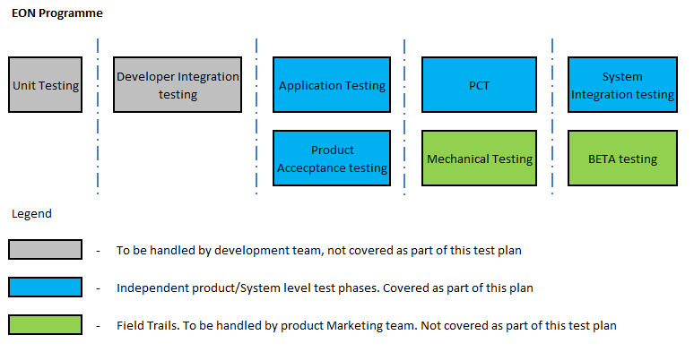

1. Unit and DIT testing:
On the software portion, the testing starts at code/module level (unit testing) and subsequently by integrating all the modules together (DIT) by developers themselves. Both these test cycles need to be handled by development team and hence the same is not covered as part of this plan.
To start the independent testing of the product, it is mandatory that Unit testing and DIT are completed. Please refer to section 2.3 Test Initiation Criteria for more details.

2. Application Testing:
Following are the strategies to be followed for Application testing,
- Each and every user workflow shall be verified for completeness and correctness (Sales).
- Verification of the application can happen directly in the POS Terminal.
- As part of the application testing, all the combination of transaction that are possible for a specific sale shall be checked for the existence .
- The boundaries shall be verified for the proper handling at the application level. For example, when an input value goes out of range, whether the application is able to handle it or not, shall be verified.

3. PAT:
Product Acceptance Testing of EON will start on the already base lined Hardware boards (the latest revision, which is released) of Field Interface and will essentially cover all the functionalities of the Field Interface in user perspective.

- Tool Level: To evaluate the new features of the complete system in user perspective in detail. This will be carried out in all the supporting environments (Different Site controllers).

As the PAT tester will play the role of the user during testing, only the external interfaces (software user interfaces, Hardware switches ) will be used and considered for testing.

Following are the strategies to be followed for PAT,
- Testing will be done using the Black box testing approach. Both Field Interface and configuration tool will be the black box for the PAT tester and the internal development details and restrictions of each of these will not be considered for testing. To support the Black box testing approach, any requirement that requires the usage of interfaces other than the external interfaces (that requires code level testing) should be carried out by design team.
- Third party integration testing will not in the scope of PAT except pump control
- There is no Migration testing planned as part of PAT as there is no direct path for the migration of existing system to new EON based system.
4. PCT:
All the performance related requirements as specified in PRS shall be verified and recorded as part of PCT testing in all the relevant test scenarios. The performance requirements shall be validated in Minimum, Medium and Maximum system loads. The PCT test plan shall define what is meant by Minimum, Medium and Maximum loads in EON system’s context.
In addition, longevity test shall also be planned as part of the PCT cycle.
Please refer to the 6.4 PCT and Longevity Test bed section for more details.

5. Mechanical Testing:
.

6. SIT:
System Integration Testing shall essentially validate all the complete engineering work flow of the POS system in the test environment which is as close as field milieu.
As part of engineering work flow test through POS, the evaluation shall proceed all the way till the pump controllers get monitored in POS in custom graphics as in field with increased number of pump controllers in the proprietary Channel with different networking scenarios.
A real POS system with all the different types of pheriparals, ERP, payment gateway, etc. shall be added in the test bed for the pervasive verification for the system under test. These SIT systems shall be put into test atleast for a week’s time for the evaluation of the stability of the system.

7. BETA:
BETA testing shall be handled by Product marketing team by choosing varying capacity of customers for the field trials of the system before the General Release. The details of the same are not captured as part of this test plan...

Requirements Coverage Goals
The following are the requirements coverage Goals for this project –
- 100% coverage should be achieved on the new Functional requirements of this project through Application testing, PAT, PCT, and SIT testing. This shall be evaluated through the Traceability matrix from new functional requirements to Application testing, PAT, PCT and SIT test cases.
- All the ilities related requirements (Performance, Capacity, and Interoperability/compatibility) shall be covered 100% as part of PCT and SIT test cycles. However, this does not include the hardware reliability testing, as there is no hardware change for this program. There shall not be any security testing as part of this program.

Test Initiation Criteria
To start PAT testing,
- The build has to pass the PAT SGR (Stage Gate Review).
- Successful completion of Unit Test and Developer Integration test and repot for the same shall be available. However, if any portion of the deliverable (e.g. Firmware piece) does not call for Unit testing, then the same can be waived off.
- Memory Leak testing should have done as part of Unit testing/DIT and report for the same shall be available.
- PAT Test Case Design Document should be complete and base lined. All the test cases must have been reviewed and approved.
- Already released hardware boards and firmware versions must be available. There shall not be any further changes in Hardware, firmware planned. ( Field Interface )
- PAT Test bed should be ready.
- Turn over document must be provided with Impact analysis for the fixes of issues with previous builds.
- Should not have any Priority-1 defects in open state and should not be more than 2 Priority-2 and 5 Priority-3/Priority-4 defects in open state. These defects count refer to the new issues found during Unit testing and DIT levels only and it does not refer to the Legacy Spyder and\or LNS Plugins defects.
NOTE 4: Any deviation from the above mentioned criteria should have an approval from CCB

To start Application Testing,
- The application built must have been unit tested by the Application developer himself for the correctness and completeness of the logic.
- Optimization of the application must have been taken care of, during development.
- There should be supporting document(s) ready which describe(s) the details of the logic and the allowed input combinations and expected results.
- Application testing test bed should be ready.
NOTE 5: Any deviation from the above mentioned criteria should have an approval from CCB

To start PCT and System Integration testing,
- The build has to pass the SIT SGR (Stage Gate Review).
- Successful completion of PAT testing and repot for the same shall be available.
- SIT Test Case Design Documents and PCT plan should be complete and base lined. All the test cases must have been reviewed and approved.
- Already released hardware boards and firmware versions must be available. There shall not be any further changes in Hardware, firmware planned.
- SIT/PCT Test bed should be ready.
- Turn over document must be provided with Impact analysis for the fixes of issues with previous builds.
- Should not have any Priority-1 defects in open state and should not be more than 2 Priority-2 and 5 Priority-3/Priority-4 defects in open state.
NOTE 6: Any deviation from the above mentioned criteria should have an approval from CCB

Test Completion Criteria
For both PAT and PCT/SIT phases, testing will be carried out on the build(s) till achieving successful execution of all the test cases identified for PAT/SIT. Product Acceptance Test and System Integration Test (along with PCT) of this system are complete when 100% of the test cases planned have been executed and all Priority-1 and Priority-2 Defects have been resolved, re-tested.
For Application testing, testing shall be carried out on the revised application logic(s) till achieving the thoroughness and optimization in the application(s).
- 100% coverage of all the test cases that are identified for execution during PAT, PCT, Application testing and SIT.
- No Priority-1 or Priority-2 defects should be in open/deferred state. All of them must have been resolved and retested.
- There should not be more than 5 Priority-3/Priority-4 defects in open state. If more defects are present then CCB will approve the entry to Beta/release.
- It has to pass the release SGR.
NOTE 7: Any deviation from the above mentioned criteria should have an approval from CCB

Test Suspension/Resumption Criteria
Build/Application logic shall be rejected and test shall be suspended if it doesn’t pass Sanity/Smoke testing and/or has any Critical/Show stopper defect(s) which are blocking the testing of any major feature(s) and/or more than 15% of the planned test cases have failed.
Once the issues contributing to the build/application rejection are fixed, and unit and DIT tested, test shall be resumed with the turn over of the new build.
NOTE 8: Any deviation from the above mentioned criteria should have an approval from CCB

Build Turn over Process
A Turn Over mail will be initiated by Project lead to all Stake Holders once the build is ready for independent testing. This mail will essentially have the details of build location and installation steps. Turn Over document must be attached with this mail covering the details of the fixed defects and new/impacted functionalities to be verified.
For the application testing, the developed application along with the supporting document(s) shall be made available to start the testing.
Test Entry meeting will be initiated by Test Lead upon receiving the build from development team to discuss the Test prioritization and impacted areas, on need basis.
Test team will not accept any intermediate builds during the course of the testing without the CCB approval.

Types of Testing
The following are the different types of testing that are planned across PAT and SIT phases

Functional Testing
The scope of Functional testing is to test all the Functional Requirements of POS as specified in PRS. This would span across PAT testing phases.

Following testing will be carried out as part of functional testing,
- Smoke/Sanity Test: This testing will be employed by the testing team to accept a build for further testing. This will be a spot test of the product where identified test cases will be executed for the vital few requirements. The build will be accepted if all the identified test cases are (100%) passed.
- Functional Test at Tool/System level: This will cover the details of the system level new functional changes in detail on POS with respect to Field Interface. This shall be designed based on the functional requirements as specified in PRS.
- Regression Testing: Regression testing will be performed on the impacted areas in general, based on the fixes (defects fixing) as identified by the development team.

Test Case Generation Approach
- Smoke/Sanity Test: Test cases shall be prepared to cover the vital few requirements.
- Functional Test at Tool/System level: Test cases shall be prepared to cover the details of the system level new functional changes in detail. This shall be designed based on the functional requirements as specified in PRS.
- Regression Testing: TBD
NOTE 9: All the above test cases shall be prepared in JIRA, except for Smoke test cases which will be in Excel format.

Test Reuse Approach
TBD.

Test Automation Approach
TBD

Test Prioritization Approach
Tests cases will not have individual priority flags. However, the thoroughness of the new features will be given first priority over the regression on the existing features during testing.

Application testing
Application testing shall be carried out as soon as the applications are ready for independent evaluation. The scope of the application testing is to verify the correctness and completeness of the application.

Test Case Generation Approach
Application test cases will be generated based on the input and output type combinations, boundary values of each inputs etc.
- Application test cases should have the means to test all the combination of inputs ( Sale ) that are possible for a given application . The effect of each of these inputs with respect to outputs shall also be defined in the test cases.
- The boundaries shall be defined in the application test cases for the proper handling at the application level. For example, when an input value goes out of range, whether the application is able to handle it or not, shall be verified through the application test cases.
For generating application test cases, both PRS as well as the application/interface description document of Rich Wruck shall be referred.

Test Reuse Approach
Application testing test cases shall be written new for POS. There is no reuse plan here.

Test Automation Approach
There is no automation plan for Application testing.

Capacity and Performance Testing
Capacity and Performance test shall essentially test the Performance and Capacity limits of the POS system, as defined in PRS.

Test Case Generation Approach
An excel sheet shall be prepared which will constitute the different system level user operations (e.g. configuration, downloading etc.) to be tested at the peak load (what is meant by peak to be elaborated in the PCT plan, so that tester can make sure to load the system accordingly, before taking the performance reading). This will be termed as the Performance and Capacity Test design of the POS/EON program.

Test Reuse Approach
TBD.

Test Automation Approach
There is no automation plan for PCT; it shall be carried out manually.

SIT testing
SIT shall focus on complete engineering work flow as used in field.

Test Case Generation Approach
TBD

Test Reuse Approach
TBD

Test Automation Approach
There is no automation plan for this testing.

Usability testing
Usability testing shall verify on the correctness of different user interfaces (especially the Wizards), promptness of the error status indications (e.g. error messages) and effectiveness of the different navigations on the new/modified features. If there is chance of any usability improvement, the same will be entered as Enhancements in Defect Tracking Tool. In addition, the behavior and withstandabiltiy of the system when misused (e.g. false proofing) will also be verified and if there is a chance of improvement in this area, the same will also be suggested.

Test Case Generation Approach
There shall not be any explicit test cases developed for usability testing, except for the direct UI requirements mentioned in PRS. This shall be carried out based by an experienced tester(s), who would ascertain the intuitiveness of the different user interfaces, engineering work flow of the system from user perspective.
NOTE 10: There shall not be any separate test cycle planned for Usability testing. This shall be covered as part of PAT and SIT phases.

Test Reuse Approach
Not Applicable.

Test Automation Approach
Not Applicable.

Defect logging and Tracking process

Defect Tracking Tool
JIRA will be used as Defect tracking tool for this program. Each defect will be entered in the tool with the appropriate Severity.

These Defects will also be discussed on Telecoms with stakeholders on weekly basis. However, any issue requires immediate attention, then special Telecoms can also be arranged.

Defect Severity
S.No | Severity | Description
1. | Critical (Show Stopper) | The Product crashes, resets, hangs or is otherwise unusable to the user.
2. | Major | Major functionality of the product is missing, can not be used, or doesn't work.
3. | Minor | Minor functionality of the product is missing, can not be used, or doesn't work. A work around exists or most users will not notice the defect.
4. | Marginal | An acceptable work around exists. Most users will not notice the defect. These defects include doc errors, screen layout errors, or help file errors.

Defect Life cycle
The PCR’s reported would be tracked until closure. If a new defect is in Open State, the defect would be then Assigned by the development Team Lead to the respective members depending upon the module the defect is present. Fixed defects will be moved to resolved state. Testers will then re-test and move it to Verified / Closed / Reopen state.

Configuration Management
All the documents pertaining to the testing activities including test plan, test design and test report will be maintained in the location as identified in the project plan for configuration management ( Sunil has to finalize this task).

Test Cycles

Application Testing – Cycle I
Application testing cycle 1 includes,
- Lab setup
- Smoke/Sanity Test
- Application Testing
- Test report

Application Testing – Cycle II
Application testing cycle 2 includes,
- Smoke/Sanity Test
- Application Testing
- Test report
Verification: This testing is done to cross check the fixed defects in the latest build (Issues which are in resolved state in defect tracking tool). After the verification of an issue, if it is found that the issue is not fixed correctly then that issue will be re-opened again; else it will be moved to closed state.
NOTE 11: If the significant number of issues reported in PAT cycle 1 are still open and/or if the tool is not stable yet and/or if new issues are found in PAT cycle 2 and/or if fixed issues are reopened in cycle 2 and/or if fixed issues introduced new issues on the previously working components, additional PAT cycle shall be planned.

PCT and longevity Test
PCT and Longevity test cycle includes,
- Lab setup
- PCT Test Design document preparation
- Performance and Capacity Testing
- Longevity testing
- Test report
- Test Design Update, if required
NOTE 14: If the capacity/performance limits are NOT in the satisfying range at the end of PCT cycle and if CCB decides to enhance the capacity/performance of the system, there shall be an additional PCT cycle on the enhanced software.

SIT – Cycle 1
SIT cycle 1 includes,
- Lab setup
- SIT Test Design document preparation
- Smoke/Sanity Test
- SIT Test execution in
- Test report
- Test Design Update, if required

SIT – Cycle 1I
SIT cycle 2 includes,
- Smoke/Sanity Test
- PCR Verification cycle
- Regression testing
- Test Report
NOTE 15: If the exit criteria of testing (as described in earlier sections) is not met, there shall be a need of additional SIT cycles.

Test Resources

Test Team
- Test Resources
Name | Title | Roles/Responsibilities
Raghuraman Swaminathan | Test Leader | Shall manage the test schedule, project the quality issues to management, track and mitigate risks, review the PCRs, facilitate the Stage Gate Reviews, facilitate procurement/shipment etc.  Shall prepare the Integrated Test plan.  Shall participate in test estimations.  Shall participate in Test bed preparations.  Shall participate in regression test suite selection.  Shall be responsible for the overall quality of the system.  Shall prepare the SIT test design document  Shall prepare the Application Test design document  Shall prepare Smoke/Sanity test design document
NOTE 16: In addition, additional test resource(s) may be added to the team during PAT and SIT test execution, on need basis.

Test Environment

TB1 – Application and PAT Test bed

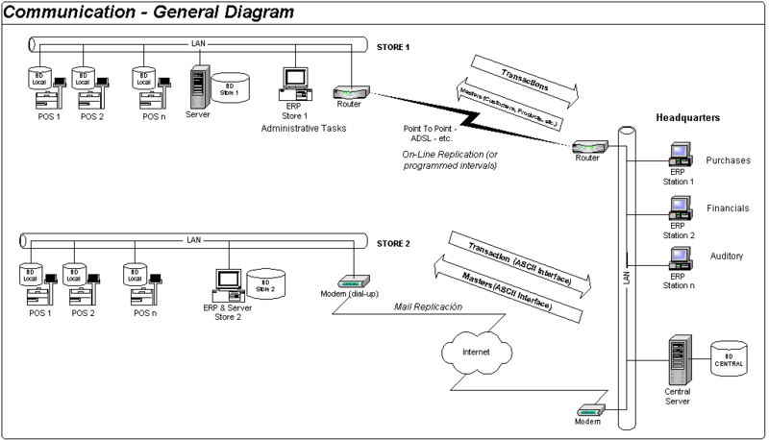

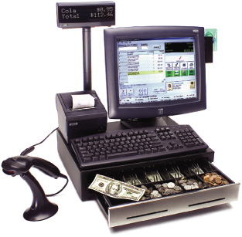

Test Execution Plan
Based on the functionalities implemented, PCRs fixed for the given build, the test execution plan shall be prepared (the applicable test cases shall be selected for the test cycle) during the test execution phase.
This shall be an on-going exercise for Test team for every test cycle and Test Team lead shall own the outcome of Test execution planning exercise. JIRA shall be used in the capacity of “Test Management Tool” for this.
The milestones, detailed Work breakdown structure (WBS) related to testing and timeline for each of the tasks involved shall be made available once the detailed estimation for testing and mpp are complete.

- Test Session Summary
Tester:
Test Cycle:
Test Suites and Test Cases Executed:
Test Session Start Date:
Test Session Completion Date:
Primary Software/Product/System Tested:
Peripherals Tested
Number of Defects Generated:
Tester Comments:
The above table shall be used as part of the Test Summary section of Test Report at end of each test cycle.

